A000-US-TN-Johnson County-Truncated Tube-Stone-1000 CE

**Case no.: 13**

**Accession Number:**

**Formal Label:**

US-TN-Johnson County-Truncated Tube-Stone-1000 CE

**Display Description:**

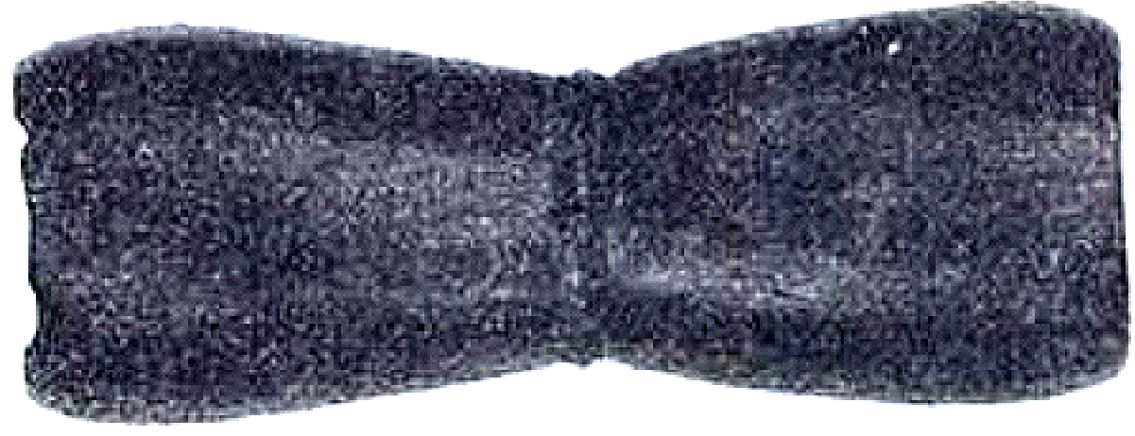

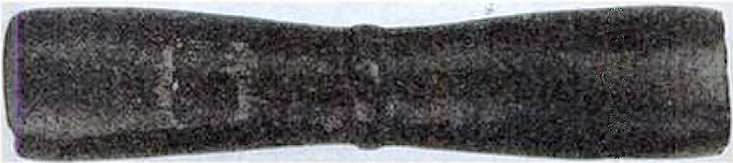

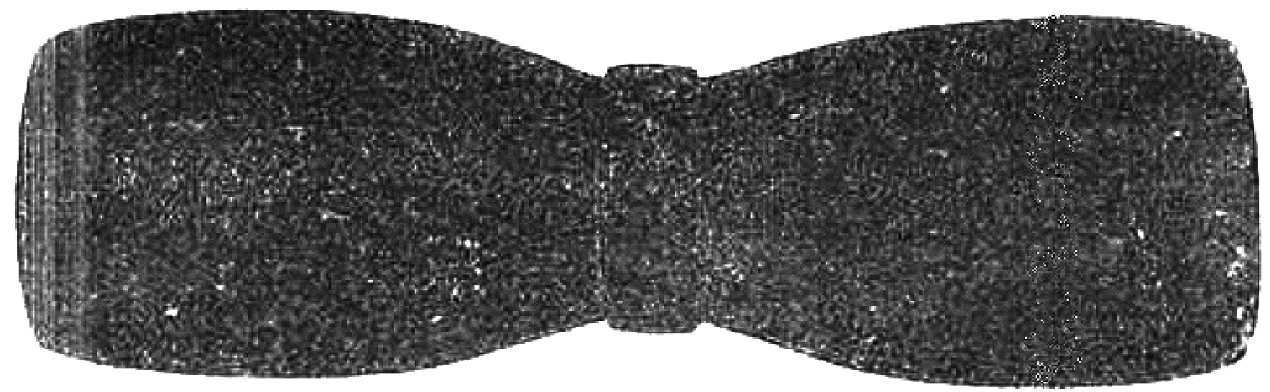



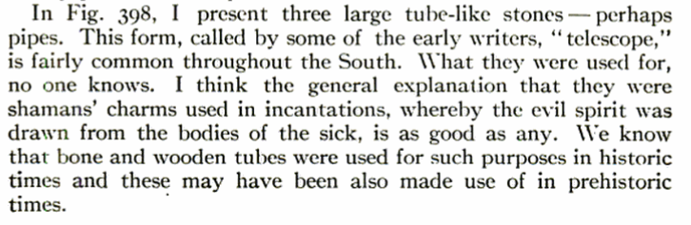

After Moorehead 1910 1: 457, 455.

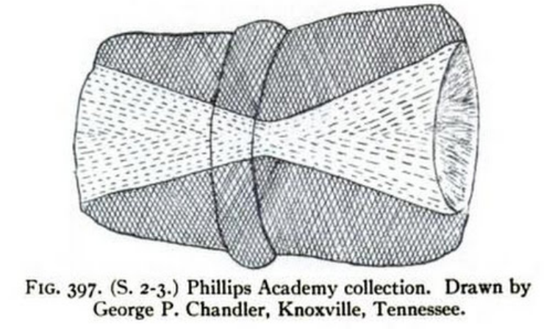

After Moorehead 1910 1:456.

**LC Classification:**

**Date or Time Horizon:**

**Geographical Area:**

**Map:**

**GPS coordinates:**

**Cultural Affiliation:**

**Media:** **Dimensions:**

**Weight:**

**Condition:**

**Provenance:**

**Discussion:**

**References:**

Moorehead, Warren King. 1910, The stone age in North America; an archæological encyclopedia of the implements, ornaments, weapons, utensils, etc., of the prehistoric tribes of North America, with more than three hundred full-page plates and four hundred figures illustrating over four thousand different objects, by Warren K. Moorehead ...Boston, New York: Houghton Mifflin Company,